***CloudNix Frontend Assignment***

**Step-1: Theme Selection**

**Code:-**

<!DOCTYPE html>

<html lang="en">

<head>

    <meta charset="UTF-8">

    <meta name="viewport" content="width=device-width, initial-scale=1.0">

    <link href="https://cdn.jsdelivr.net/npm/bootstrap@5.2.3/dist/css/bootstrap.min.css" rel="stylesheet" integrity="sha384-rbsA2VBKQhggwzxH7pPCaAqO46MgnOM80zW1RWuH61DGLwZJEdK2Kadq2F9CUG65" crossorigin="anonymous">

    <script src="https://cdn.jsdelivr.net/npm/@popperjs/core@2.11.6/dist/umd/popper.min.js" integrity="sha384-oBqDVmMz9ATKxIep9tiCxS/Z9fNfEXiDAYTujMAeBAsjFuCZSmKbSSUnQlmh/jp3" crossorigin="anonymous"></script>

    <script src="https://cdn.jsdelivr.net/npm/bootstrap@5.2.3/dist/js/bootstrap.min.js" integrity="sha384-cuYeSxntonz0PPNlHhBs68uyIAVpIIOZZ5JqeqvYYIcEL727kskC66kF92t6Xl2V" crossorigin="anonymous"></script>

    <link href="https://cdn.jsdelivr.net/npm/bootstrap@5.3.0-alpha1/dist/css/bootstrap.min.css" rel="stylesheet" integrity="sha384-GLhlTQ8iRABdZLl6O3oVMWSktQOp6b7In1Zl3/Jr59b6EGGoI1aFkw7cmDA6j6gD" crossorigin="anonymous">

    <title>Shpnix-Theme</title>

    <style>

      .card {

        width: 20rem;

        margin: 10px;

        border-radius: 0;

      }

      .card-img-top {

        border-radius: 0;

      }

    </style>

</head>

<body>

    <div class="container mt-5 px-0 d-flex flex-wrap justify-content-center">

        <div class="card mx-4 my-4">

          <img

            src="https://admin.shopnix.io/static/images/themes/layout3/l3-bags.webp"

            class="card-img-top img-fluid" alt="There is a blog image">

          <div class="card-body d-flex align-items-center flex-column mb-4">

            <p class="card-title p-3 fs-2" style="font-size: 2px;"><b>Bag Themes</b></p>

            <a href="#" class="btn btn-outline-danger fs-5">Apply</a>

          </div>

        </div>

        <div class="card mx-4 my-4">

          <img

            src="https://admin.shopnix.io/static/images/themes/layout3/l3-chic.webp"

            class="card-img-top" alt="There is a blog image">

          <div class="card-body d-flex align-items-center flex-column mb-4">

            <h5 class="card-title p-3 fs-2">Chic theme</h5>

            <a href="#" class="btn btn-outline-warning fs-5">Apply</a>

          </div>

        </div>

        <div class="card mx-4 my-4">

          <img

            src="https://admin.shopnix.io/static/images/themes/layout3/l3-flex.webp"

            class="card-img-top img-fluid" alt="There is an image">

          <div class="card-body d-flex flex-column align-items-center mb-4">

            <h5 class="card-title p-3 fs-2">Flex theme</h5>

            <a href="#" class="btn btn-outline-success fs-5">Apply</a>

          </div>

        </div>

    </div>

    <div style="text-align: right;">

      <button style="margin-right: 20px;">Next</button>

   </div>

</body>

</html>

**Output:**

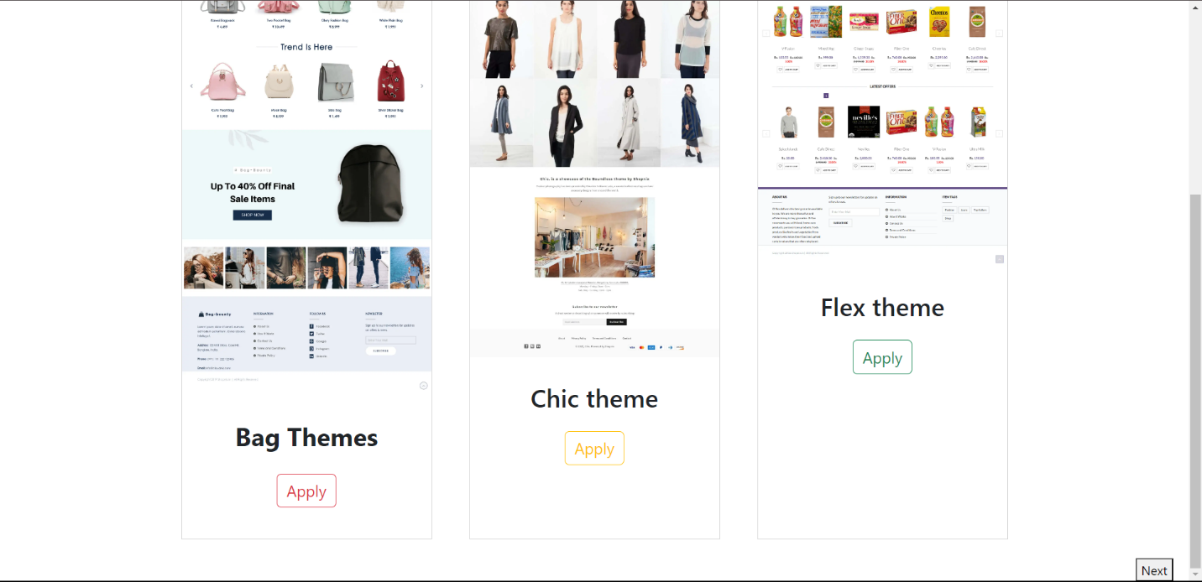

**Step-2:**

**Code:**

<!DOCTYPE html>

<html lang="en">

<head>

  <meta charset="UTF-8">

  <meta name="viewport" content="width=device-width, initial-scale=1.0">

  <title>Category</title>

  <style>

    body {

      font-family: 'Arial', sans-serif;

      margin: 20px;

    }

    form {

      max-width: 600px;

      margin: 0 auto;

    }

    label {

      display: block;

      margin-bottom: 8px;

    }

    input, select {

      width: 100%;

      padding: 8px;

      margin-bottom: 16px;

      box-sizing: border-box;

    }

    .button-container {

      display: flex;

      justify-content: flex-end;

    }

    button {

      color: white;

      padding: 10px 15px;

      border: none;

      border-radius: 5px;

      cursor: pointer;

      margin-left: 10px;

    }

  </style>

</head>

<body style="background-color:aliceblue;" >

    <div>

        <p style="text-align: center; font-size:larger;"><b>Lets add a type, category and sub category</b></p>

<form style="margin: auto; width: 2200px;">

  <label for="productType">Add a product type:</label>

  <select id="productType" name="productType">

    <option value="clothing">Clothing</option>

    <option value="electronics">Electronics</option>

    <option value="accessories">Accessories</option>

  </select>

  <label for="category">Add a Category(optional):</label>

  <select id="category" name="category">

  </select>

  <label for="subCategory">Add a Subcategory(Optional):</label>

  <select id="subCategory" name="subCategory">

  </select>

  <div class="button-container">

    <button type="button" onclick="goBack()" style="color: black;">Back</button>

    <button type="button" onclick="goNext()" style="background-color: rgb(0, 174, 255);">Next</button>

  </div>

</form>

</div>

<script>

  function goBack() {

    alert('Navigating back');

  }

  function goNext() {

    alert('Navigating to the next step');

  }

</script>

</body>

</html>

**Output:**

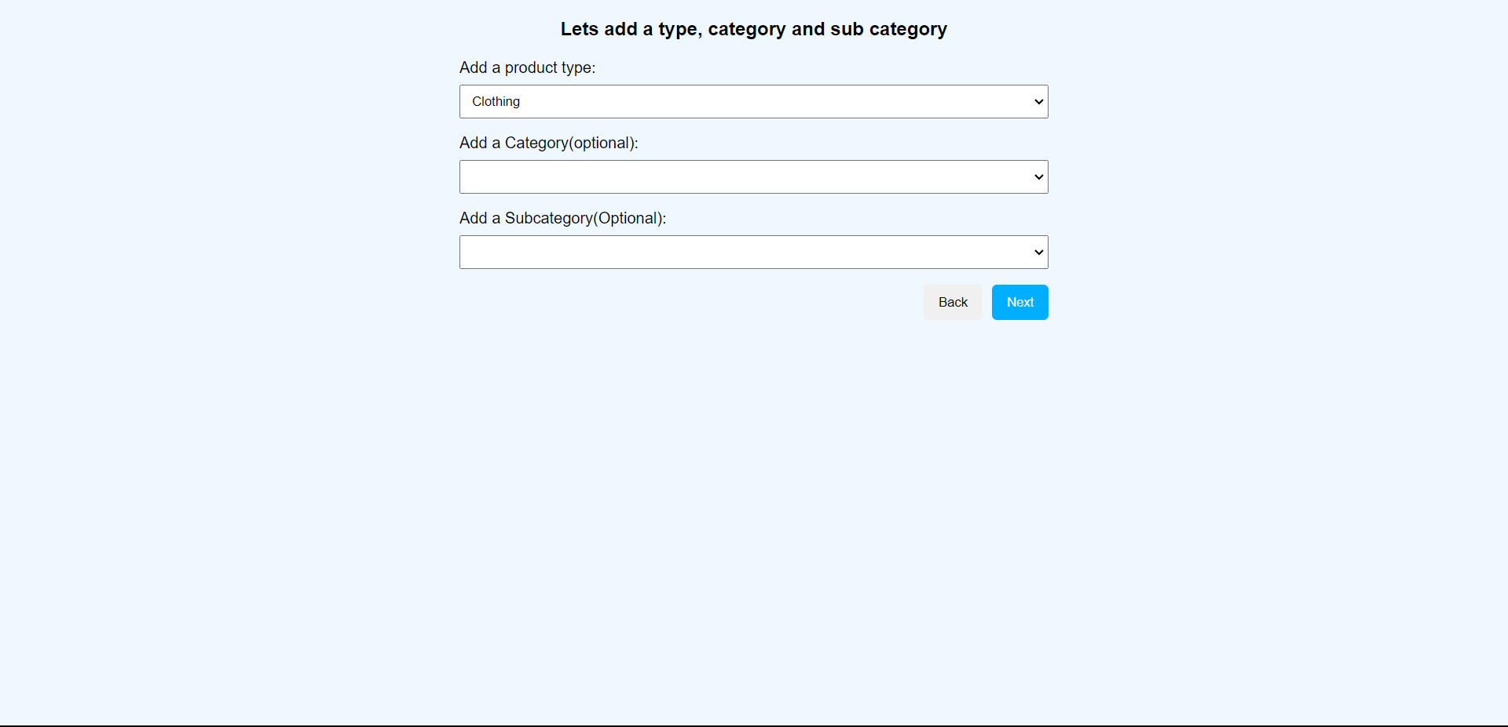

**Step-3:**

**Code:**

<!DOCTYPE html>

<html lang="en">

<head>

    <title>ADD Product</title>

  <meta charset="UTF-8">

  <meta name="viewport" content="width=device-width, initial-scale=1.0">

  <style>

    body {

      font-family: Arial, sans-serif;

      margin: 0;

      padding: 0;

      overflow: hidden;

    }

    #container {

      display: flex;

      height: 100vh;

    }

    #left {

      flex: 1;

      overflow-y: auto;

      padding: 20px;

      background-color: #f0f0f0;

    }

    #right {

      flex: 1;

      padding: 20px;

    }

    h2 {

      margin-bottom: 10px;

    }

    form {

      max-width: 400px;

    }

    form label {

      display: block;

      margin-bottom: 8px;

    }

    form input,

    form textarea {

      width: 100%;

      padding: 8px;

      margin-bottom: 16px;

      box-sizing: border-box;

    }

    hr {

      margin: 20px 0;

      border: none;

      border-top: 1px solid #ccc;

    }

    .pricingDetails {

      display: flex;

      justify-content: space-between;

    }

    .pricingColumn {

      flex: 1;

    }

    #productDetails {

      border: 1px solid #ccc;

      padding: 10px;

      background-color: #fff;

      border-radius: 8px;

    }

    #productImage {

      max-width: 100%;

      height: auto;

    }

    .productTitle {

      font-size: 24px;

      margin-bottom: 10px;

    }

    .productDescription {

      border: 1px solid #000;

      padding: 10px;

      background-color: #fff;

      border-radius: 8px;

    }

    #productPrice {

      font-size: 18px;

      font-weight: bold;

      color: green;

    }

    .buttonContainer {

      display: flex;

      justify-content: space-between;

      margin-top: 20px;

    }

    .buttonContainer button {

      padding: 10px;

      font-size: 16px;

      cursor: pointer;

    }

  </style>

</head>

<body>

  <div id="container">

    <div id="left">

      <h2>Let's add your first product</h2>

      <p>Basic details</p>

      <form>

        <label for="productName">Product Name:</label>

        <input type="text" id="productName" name="productName" required>

        <label for="productDescription">Product Description:</label>

        <textarea id="productDescription" name="productDescription" rows="4" required></textarea>

        <label for="productImage">Add Image:</label>

        <input type="file" id="productImage" name="productImage">

        <label for="skuCode">SKU Code:</label>

        <input type="text" id="skuCode" name="skuCode" required>

        <hr>

        <div class="pricingDetails">

          <div class="pricingColumn">

            <label for="listPrice" style="padding-bottom: 8px;">List Price:</label>

            <input type="text" id="listPrice" name="listPrice" required>

            <label for="priceInclusiveGST" style="padding-bottom: 8px;">Price Inclusive of GST:</label>

            <input type="text" id="priceInclusiveGST" name="priceInclusiveGST" required>

            <label for="netPrice" style="padding-bottom: 8px;">Net Price:</label>

            <input type="text" id="netPrice" name="netPrice" required>

          </div>

          <div class="pricingColumn">

            <label for="discountPercentage" style="padding-bottom: 8px;">Discount Percentage:</label>

            <input type="text" id="discountPercentage" name="discountPercentage" required>

            <label for="shippingCharges" style="padding-bottom: 8px;">Shipping Charges:</label>

            <input type="text" id="shippingCharges" name="shippingCharges" required>

            <label for="stockLevel" style="padding-bottom: 8px;">Stock Level:</label>

            <input type="text" id="stockLevel" name="stockLevel" required>

          </div>

        </div>

        <div class="buttonContainer">

          <button type="button">Back</button>

          <button type="button">Next</button>

        </div>

      </form>

    </div>

    <div id="right">

      <div id="productDetails">

        <img id="productImage" src="https://cdn.thewirecutter.com/wp-content/media/2022/10/laptopstopicpage-2048px-2102-2x1-1.jpg?auto=webp&quality=75&crop=2:1&width=980&dpr=2" alt="Product Image">

        <div class="productTitle">Apple Mackbook Air M2</div>

        <div class="productDescription">

            The MacBook Air M2 is the best laptop for those willing to spend a little bit more for a great laptop. It delivers top-notch performance, over 14 hours of battery life and a bright and colorful display all in a delightfully portable design .</div>

        <div id="productPrice">Price: Rs. 1,30,000</div>

      </div>

    </div>

  </div>

</body>

</html>

**Output:**

